This is a sample of the resources Legato Strategic Consulting provides through dedicated support to institutions like yours.

Academic Calendar Set-Up

Use this guide to set up your academic calendar.

NON-INSTRUCTIONAL DAYS

Security Domain Access Needed:
- Set-Up: Time Off Domain - Modify Access (Time Off and Leave Functional Area)
- Set-Up: Calendar - Modify Access (System Functional Area)
- Set-Up: Academic Calendar - Modify Access (Academic Foundation)
It makes sense for the Registrar to have this access to these non-Student areas because that is where the non-instructional days need to be set up.
- Go to prior non- instructional days. Open up a template
- Go to View Holiday Calendar
- Create a calendar event
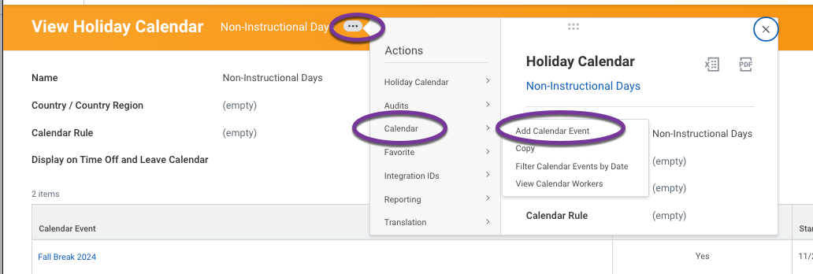
- Follow template
- Academic Calendar will automatically update with the non-instructional days

